**State Space Modeling**

**Topics Covered**

• Rotary pendulum modeling.

• Introduction to state-space models.

• Model validation.

**Prerequisites**

• Integration laboratory experiment.

• First Principles Modeling laboratory experiment.

• Pendulum Moment of Inertia laboratory experiment.

• Rotary pendulum module is attached to the QUBE-Servo 2.

**1 Background**

**1.1 Pendulum Model**

The rotary pendulum model is shown in Figure 1.1. The rotary arm pivot is attached to the QUBE-Servo 2 system and is actuated. The arm has a length of *Lr* , a moment of inertia of *Jr* , and its angle *θ* increases positively when it rotates counter-clockwise (CCW). The servo (and thus the arm) should turn in the CCW direction when the control voltage is positive (*Vm >* 0).

The pendulum link is connected to the end of the rotary arm. It has a total length of *Lp* and it center of mass is at *Lp* /2. The moment of inertia about its center of mass is *Jp* . The rotary pendulum angle *α* is zero when it is hanging downward and increases positively when rotated CCW.

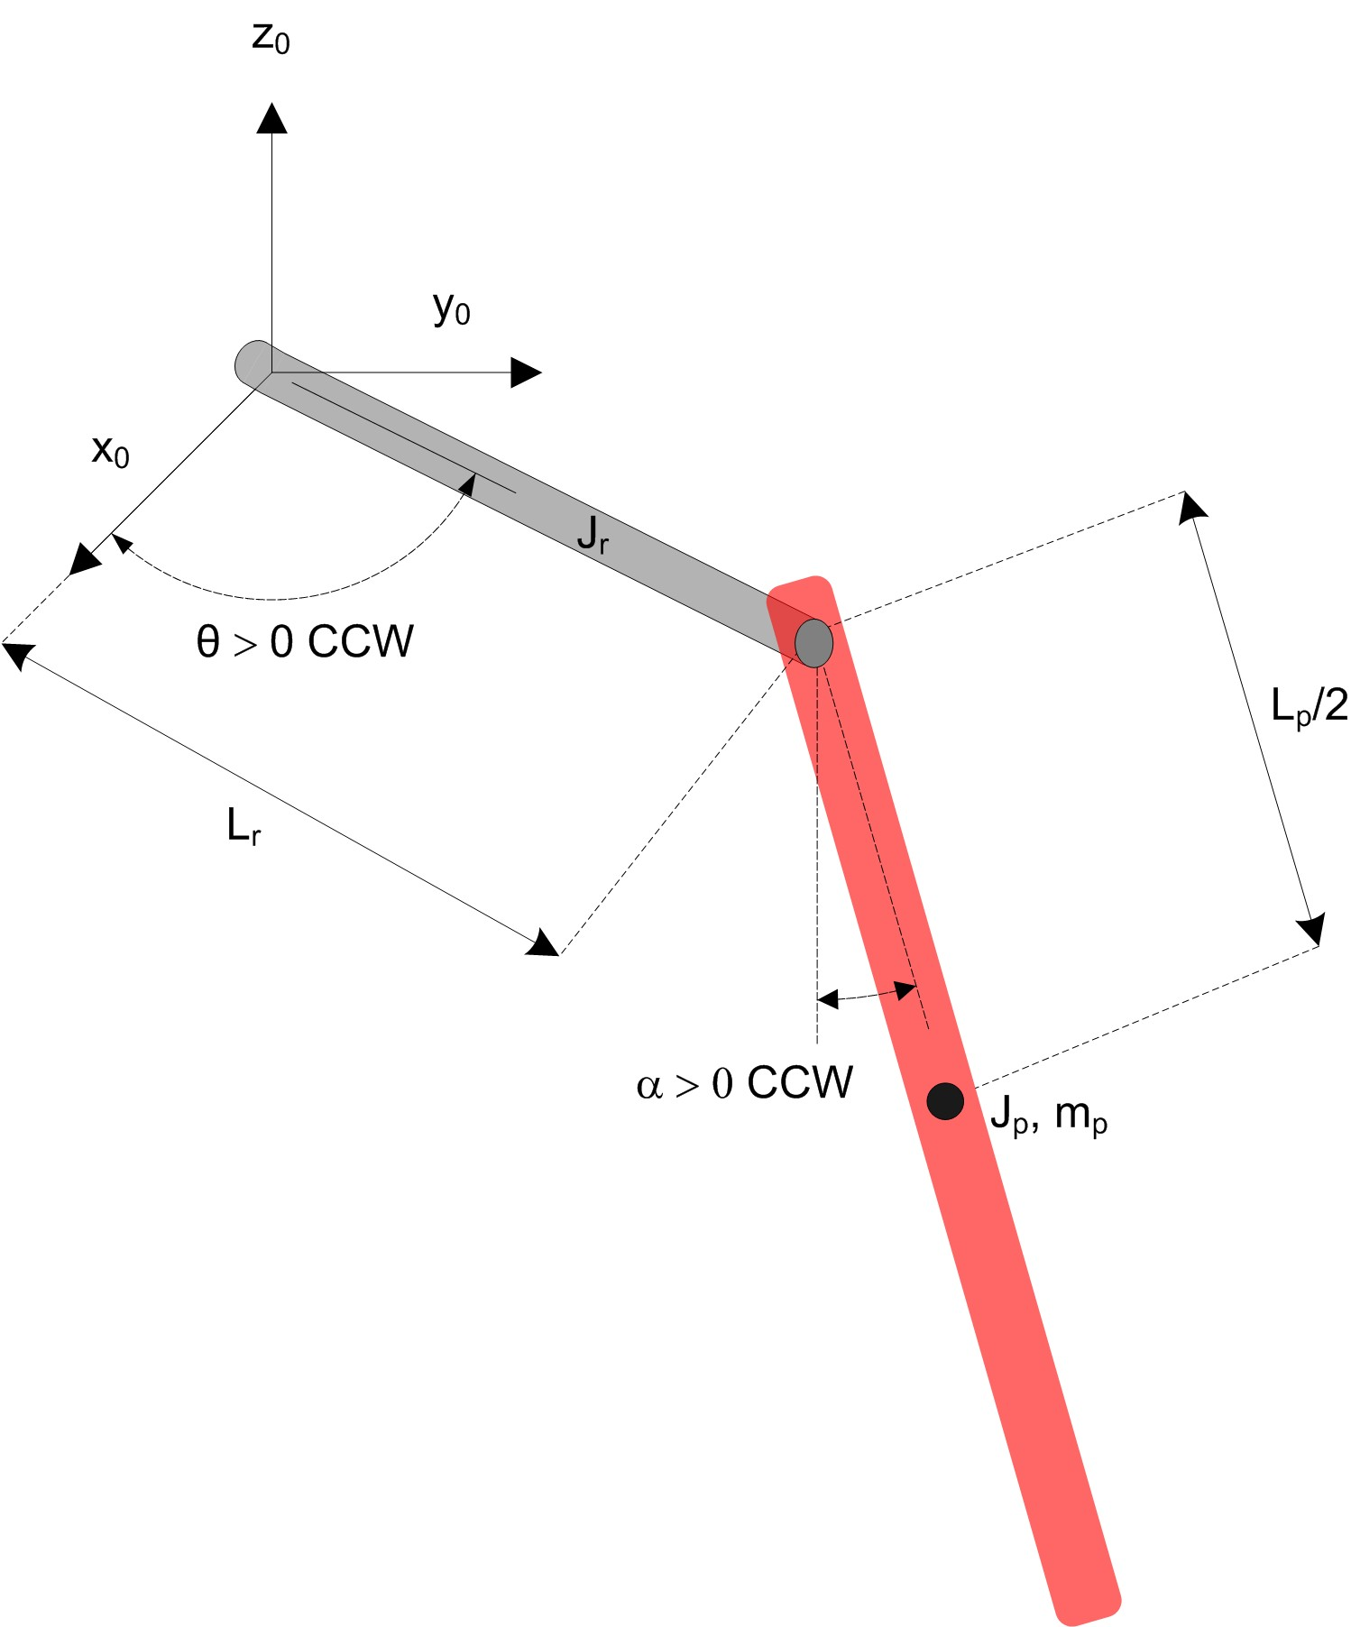

Figure 1.1: Rotary pendulum model

The equations of motion (EOM) for the pendulum system were developed using the Euler-Lagrange method. This systematic method is often used to model complicated systems such as robot manipulators with multiple joints. The total kinetic and potential energy of the system is obtained, then the Lagrangian can be found. A number of derivatives are then computed to yield the EOMs. The complete derivation of the EOM for the pendulum system are presented in the *Rotary Pendulum Modeling Summary* and Maple workbook.

The resultant nonlinear EOM are:

(

*mp L*2 +

*r*

*mp L*2 *−*

*p*

1

4

*mp L*2 cos(*α*)2 + *Jr*

*p*

1

4

) *θ*¨ +

( 1 )

2 *mp Lp Lr* cos(*α*) *α*¨

( 1

*−*

+ *mp L*2 sin(*α*) cos(*α*)

*p*

2

) *θ*˙*α*˙

( 1 )

2 *mp Lp Lr* sin(*α*)

*α*˙ 2 = *τ − Dr θ*˙

(1.1)

*mp Lp Lr* cos(*α*)*θ*¨ +

1

2

(

*Jp* +

)

*mp L*2

*p*

1

4

*α*¨ *−*

*mp L*2 cos(*α*) sin(*α*)*θ*˙2 +

*p*

1

4

1

2 *mp Lp g* sin(*α*) = *−Dp α*˙ *.* (1.2)

with an applied torque at the base of the rotary arm generated by the servo motor as described by the equation:

*km* (*Vm − km θ*˙)

*τ* = (1.3)

*Rm*

When the nonlinear EOM are linearized about the operating point, the resultant linear EOM for the rotary pendulum are defined as:

*r*

1

and

(*mp L*2 + *Jr* ) *θ*¨ +

2 *mp Lp Lr α*¨ = *τ − Dr θ*˙*.* (1.4)

*mp Lp Lr θ*¨ +

1

2

(

*Jp* +

)

*mp L*2

*p*

1

4

*α*¨ +

1

2 *mp Lp gα* = *−Dp α*˙ *.* (1.5)

Solving for the acceleration terms yields:

*θ*¨ = 1 (

(

*Jp* +

)

*mp L*2

1

*Dr θ*˙ +

1

*mp Lp Lr Dp α*˙ +

*m*2 *L*2 *Lr gα* +

1

(

*Jp* +

)

*mp L*2

1

)

*τ .* (1.6)

and

*JT −* 4 *p* 2

1 ( 1

*r*

2

4 *p p* 4 *p*

1 1 )

*r*

2

where

*α*¨ =

*JT*

*mp Lp Lr Dr θ*˙ *−* (*Jr* + *mp L*2 ) *Dp α*˙ *−*

*mp Lp g* (*Jr* + *mp L*2 ) *α −*

2 *mp Lp Lr τ*

*.* (1.7)

*JT* = *Jp mp L*2 + *Jr Jp* +

*r*

*Jr mp L*2 *.* (1.8)

4

*p*

1

**1.2 Linear State-Space Model**

The linear state-space equations are

and

*x*˙ = *Ax* + *Bu* (1.9)

*y* = *C x* + *Du* (1.10)

where *x* is the state, *u* is the control input, *A, B, C* and *D* are state-space matrices. For the rotary pendulum system, the state and output are defined

and

[

*θ α α*˙

*x* =

*θ*˙

*T*

]*T* (1.11)

*y* = [*θ α*]

*.* (1.12)

**2 In-Lab Exercises**

There are several VIs available in the LඉඊVIEW™ *Control Design and Simulation Module* to enable the creation of linear state-space models. Based on the Virtual Instrument (VI) already designed in the Rotary Pendulum Modeling lab, design a VI similar to the one shown in Figure 2.1 that applies a 1 Hz square wave with an amplitude of 1 V to the pendulum system and state-space model.

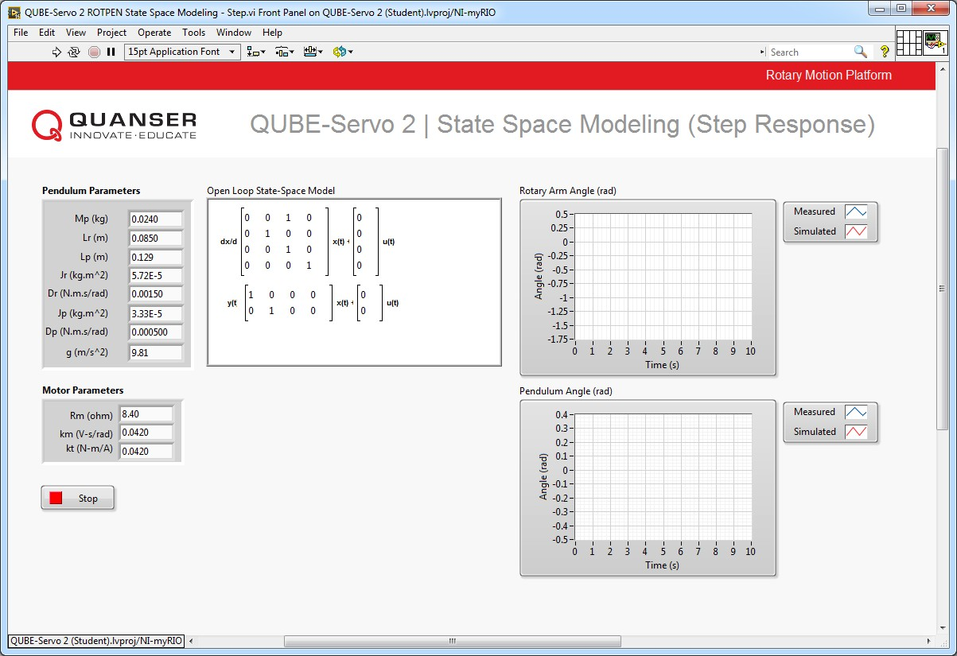

(a) Front Panel

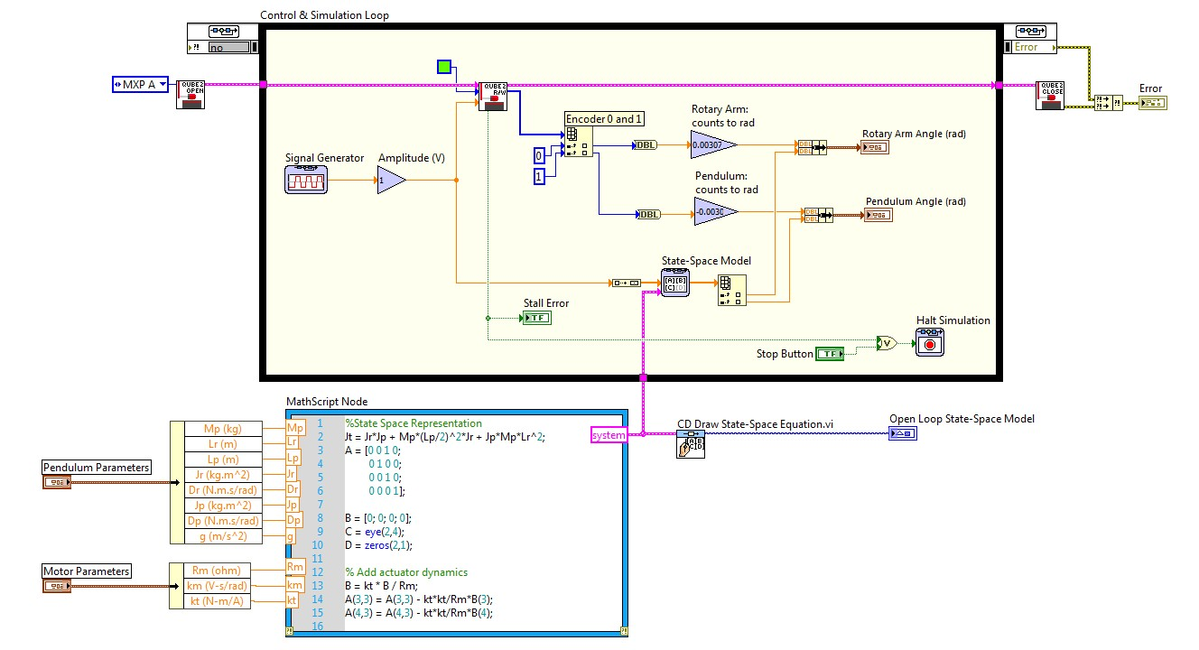

(b) Block Diagram

Figure 2.1: Applies a step voltage and displays measured and simulated pendulum response.

There are several methods that can be used to create the state-space model in LඉඊVIEW™. The method shown in Figure 2.1 utilizes the *MathScript RT Module* to create the model, which is then passed to the *State-Space* VI for simulation.

**Note:** Be sure to include the actuator dynamics in your model, as shown in Figure 2.1.

1. Based on the sensors available on the pendulum system, find the *C* and *D* matricies in Equation 1.10.

2. Using Equation 1.6 and Equation 1.7 and the defined state in Equation 1.11, derive the linear state-space model of the pendulum system.

3. Input the linear state-space model into the MathScript Node. Using the CD Draw State-Space Equation VI shown in Figure 2.1, verify that you have entered the correct matrices.

4. Set the rotary arm viscous damping coefficient *Dr* = 0*.*0015 N *−* m *−* s/rad, and the pendulum damping coefficient *Dp* = 0*.*0005 N *−* m *−* s/rad. These parameters were found experimentally to reasonably accurately reflect the viscous damping of the system due to effects such as friction, when subject to a step response.

5. Run the VI. The scope response should be similar to Figure 2.2. Attach a screen capture of your scopes. Does your model represent the actual pendulum well? If not, explain why there might be discrepancies.

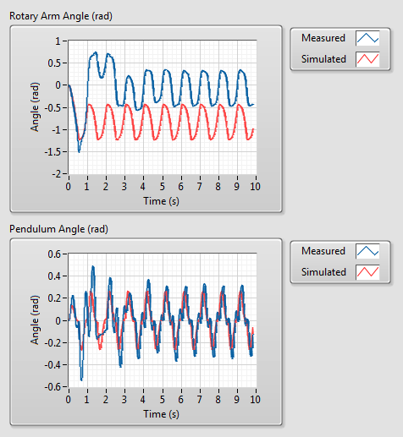

Figure 2.2: Step response of the pendulum system

6. The viscous damping of each pendulum can vary slightly from system to system. If your model does not accurately represent your specific pendulum system, try modifying the damping coefficients *Dr* and *Dp* to obtain a more accurate model.

© 2019 Quanser Inc., All rights reserved.

Quanser Inc.

119 Spy Court

Markham, Ontario

L3R 5H6

Canada

[info@quanser.com](mailto:info@quanser.com)

Phone: 1-905-940-3575

Fax: 1-905-940-3576

Printed in Markham, Ontario.

For more information on the solutions Quanser Inc. offers, please visit the web site at:

[http://www.quanser.com](http://www.quanser.com/)

This document and the software described in it are provided subject to a license agreement. Neither the software nor this document may be used or copied except as specified under the terms of that license agreement. Quanser Inc. grants the following rights: a) The right to reproduce the work, to incorporate the work into one or more collections, and to reproduce the work as incorporated in the collections, b) to create and reproduce adaptations provided reasonable steps are taken to clearly identify the changes that were made to the original work, c) to distribute and publically perform the work including as incorporated in collections, and d) to distribute and publicly perform adaptations. The above rights may be exercised in all media and formats whether now known or hereafter devised. These rights are granted subject to and limited by the following restrictions: a) You may not exercise any of the rights granted to You in above in any manner that is primarily intended for or directed toward commercial advantage or private monetary compensation, and b) You must keep intact all copyright notices for the Work and provide the name Quanser Inc. for attribution. These restrictions may not be waved without express prior written permission of Quanser Inc.